Zbrajanje i oduzimanje brojeva do 10

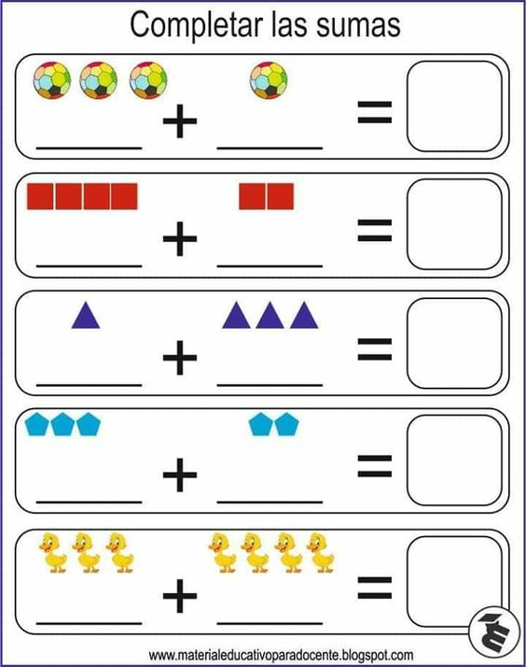

Slika preuzeta s: <https://www.pinterest.com/pin/25121710413110695/>

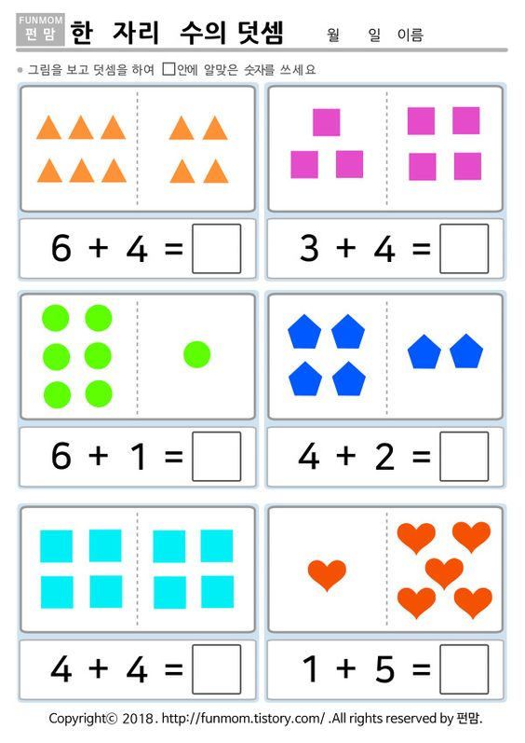

Slika preuzeta s: <https://www.pinterest.com/pin/50665564546903716/>

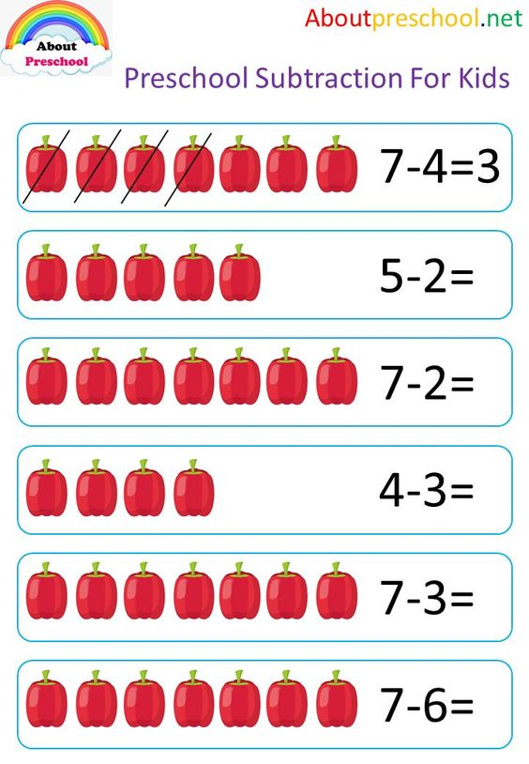

Slika preuzeta s: <https://www.pinterest.com/pin/583286589242920526/>

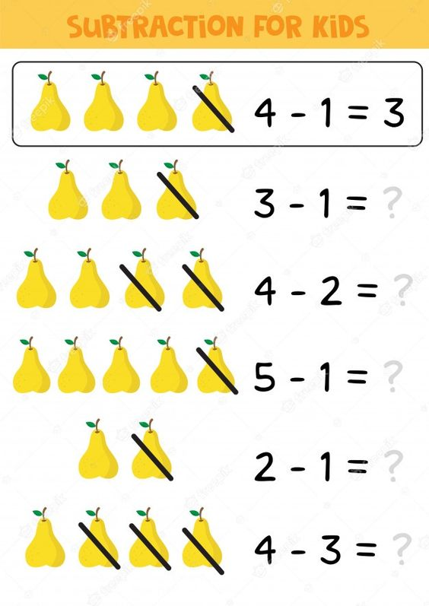

Slika preuzeta s: <https://www.pinterest.com/pin/688628599280783470/>