UTORAK, 16.3.2021. MATEMATIKA-LK

**+**

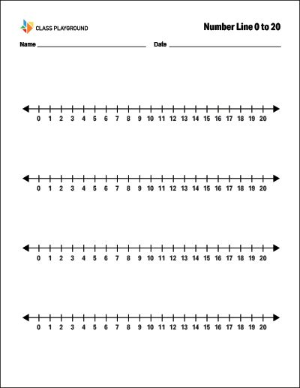

ZBROJI :

5 + 6 =

4 + 8 =

9 + 3 =

7 + 7 =

8 + 7 =

6 + 9 =

8 + 8 =

7 + 6 =

4 + 10 =

2 + 13 =

0 + 16 =

20 + 0 =