**Uz pomoć bilježnice riješi zadatke.**

1. Na crtu ispod slike zapiši ime životinja koje žive u kontinentalnoj vazdazelenoj šumi.

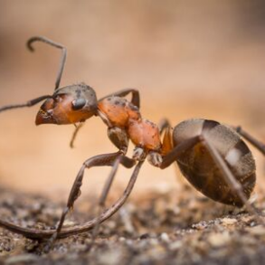 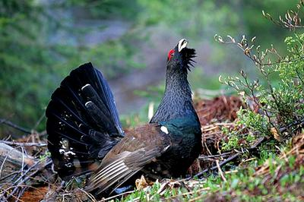

___________________ _____________________

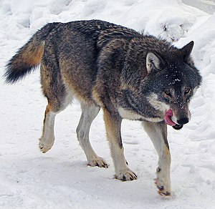 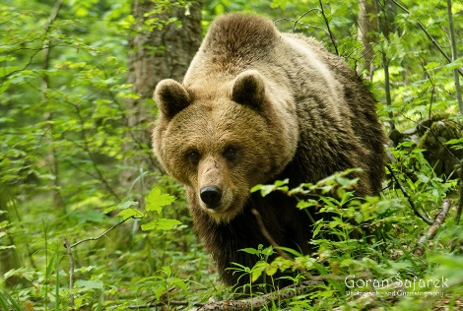

_____________________ ______________________

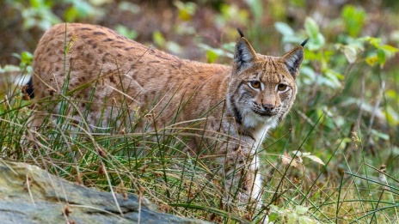 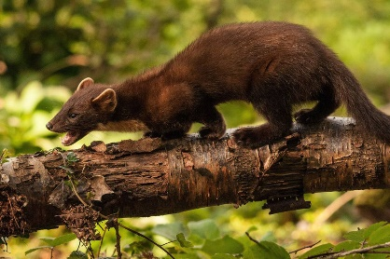

____________________ ____________________

2. Nabroji 2 ptice koje žive u kontinentalnoj vazdazelenoj šumi.

_________________________________________________________________