**ODIJEVANJE U SKLADU S VREMENSKIM PRILIKAMA**

**[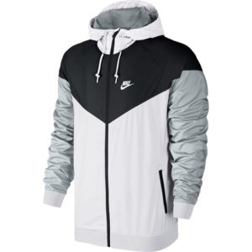](https://www.google.hr/url?sa=i&url=https://blog.sport-moda.hr/muske-jakne/&psig=AOvVaw3FD7sZ5fKMVJmHABnrmvOG&ust=1604951677372000&source=images&cd=vfe&ved=0CAIQjRxqFwoTCPCzxY_d8-wCFQAAAAAdAAAAABAV)**

**JAKNA**

**[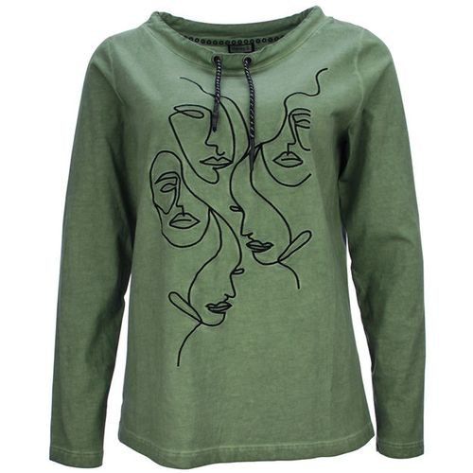](https://www.google.hr/url?sa=i&url=https://bazzar.hr/p/5Q2VN4Z-kenny-s-zenska-majica-kolekcija-jesen-2020&psig=AOvVaw3Tj0FoZnrLHqvT_rO5tood&ust=1604951889737000&source=images&cd=vfe&ved=0CAIQjRxqFwoTCNijkvbd8-wCFQAAAAAdAAAAABAH)**

**MAJICA S DUGIM RUKAVIMA**

**[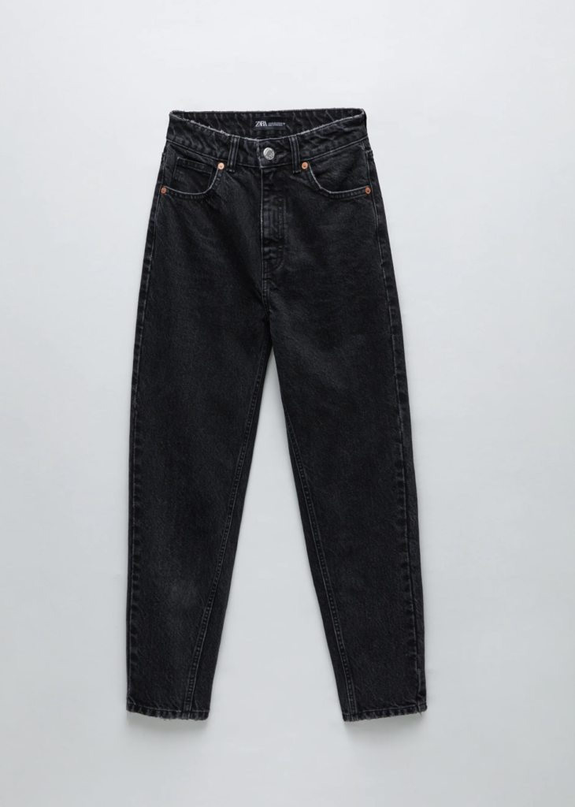](https://www.google.hr/url?sa=i&url=https://www.ljepotaizdravlje.hr/10-esencijalnih-komada-za-jesen-po-preporuci-brenda-zara/&psig=AOvVaw2ILK5QryVNbXDTKg7Yj0Z4&ust=1604952109082000&source=images&cd=vfe&ved=0CAIQjRxqFwoTCMDU89ze8-wCFQAAAAAdAAAAABAe)**

**DUGE HLAĆE**

**[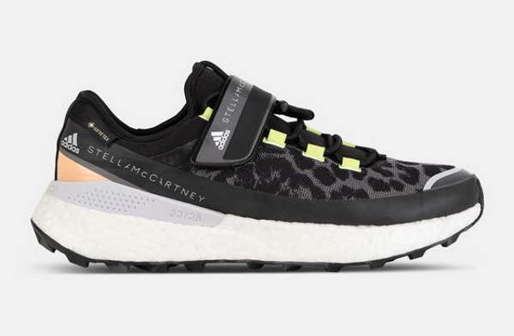](https://www.google.hr/url?sa=i&url=https://moda.covermagazin.com/?p%3D22398&psig=AOvVaw0olvZi4ecg50dgKJKLEfDb&ust=1604952301463000&source=images&cd=vfe&ved=0CAIQjRxqFwoTCJD7hLbf8-wCFQAAAAAdAAAAABAD)**

**PATIKE**

**[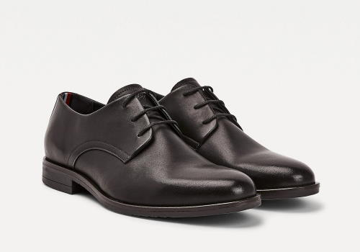](https://www.google.hr/url?sa=i&url=https://m-stil.covermagazin.com/?p%3D7990&psig=AOvVaw3o79QE7rsBV0aFpJOmhmER&ust=1604952355652000&source=images&cd=vfe&ved=0CAIQjRxqFwoTCJDYg9bf8-wCFQAAAAAdAAAAABAD)**

**CIPELE**

**[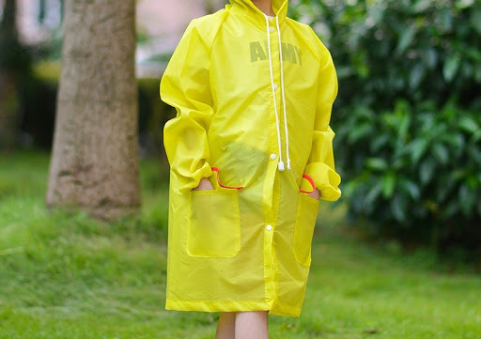](https://www.google.hr/url?sa=i&url=http://www.malenamoda.com/kabanica-erika&psig=AOvVaw3hJZUZetRk6sMu5wktDv8o&ust=1604952640215000&source=images&cd=vfe&ved=0CAIQjRxqFwoTCOi2l-Tg8-wCFQAAAAAdAAAAABAE)**

**KIŠNA KABANICA**

**[](https://www.google.hr/url?sa=i&url=https://partners.instaforex.com/en/umbrellas.php/&psig=AOvVaw2eIBqRlRAX4kEAJWywh4Ik&ust=1604952796774000&source=images&cd=vfe&ved=0CAIQjRxqFwoTCMDkpLTh8-wCFQAAAAAdAAAAABAK)**

**KIŠOBRAN**

**Pokažite djetetu sliku, neka imenuje predmet na slici i odgovori na pitanje da li taj odjevni predmet oblačimo u jesen.**

**Pitanja s ponuđenim odgovorima.**

**Kada u jesen pada kiša, trebam:**

**[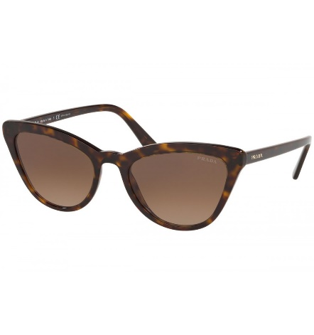](https://www.google.hr/url?sa=i&url=https://optika-oculus.hr/suncane-naocale/285-suncane-naocale-prada.html&psig=AOvVaw1JuAwjv9l1qtIAb62uVvnX&ust=1604956270124000&source=images&cd=vfe&ved=0CAIQjRxqFwoTCOivkaHu8-wCFQAAAAAdAAAAABAD)** **[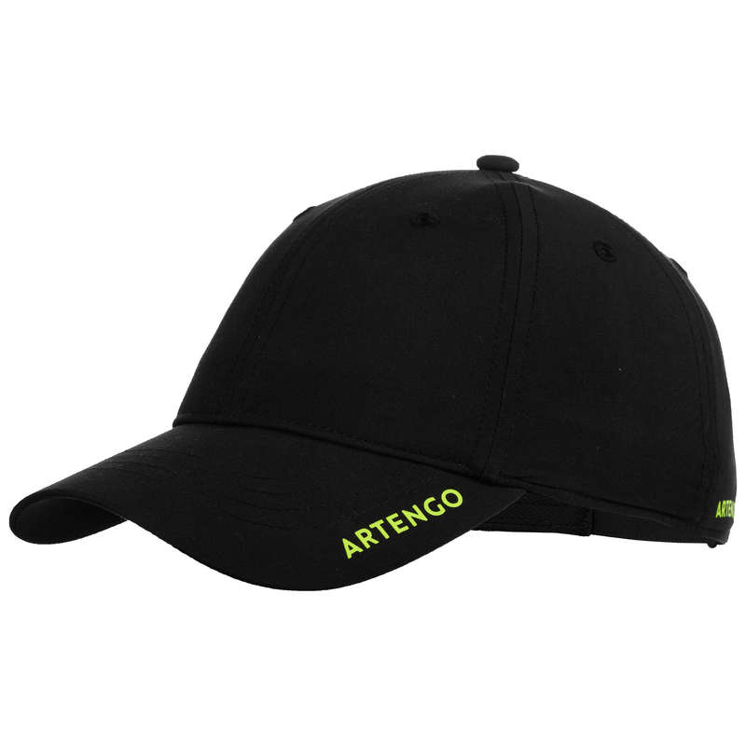](https://www.google.hr/url?sa=i&url=https://www.decathlon.hr/silterica-tc-500-54-cm-id_8525603.html&psig=AOvVaw0hac2nxjf59ARgqdF6WBya&ust=1604956360385000&source=images&cd=vfe&ved=0CAIQjRxqFwoTCIjkhszu8-wCFQAAAAAdAAAAABAD)** 

SUNČANE NAOČALE ŠILTERICU KIŠOBRAN

**Kada u jesen postane hladnije, trebam obući majicu:**

**[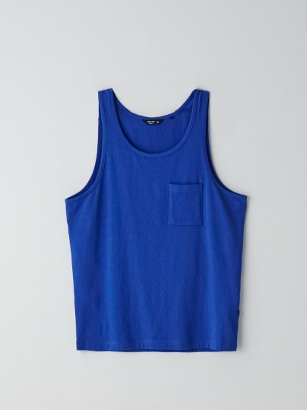](https://www.google.hr/url?sa=i&url=https://www.cropp.com/hr/hr/yj191-54x/men-s-t-shirt&psig=AOvVaw1cNp1dnb6SNdMElG3vrD0I&ust=1604956664998000&source=images&cd=vfe&ved=0CAIQjRxqFwoTCIDv8tfv8-wCFQAAAAAdAAAAABAD) [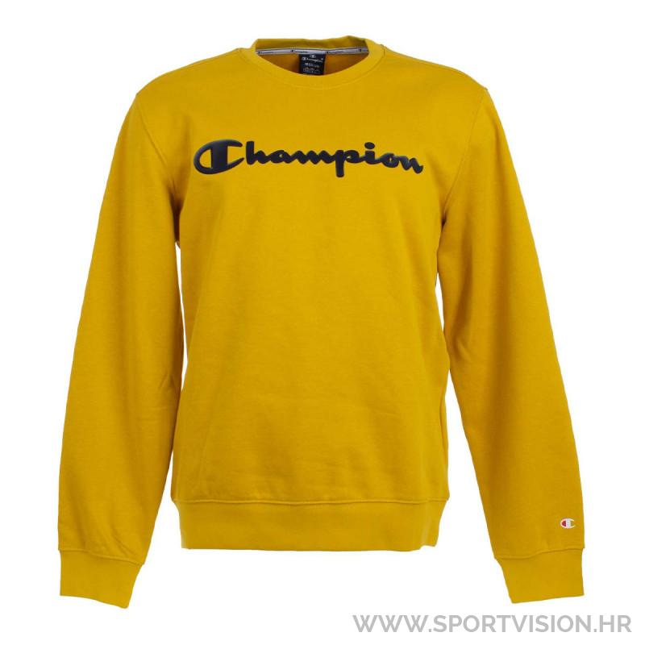](https://www.google.hr/url?sa=i&url=https://www.sportvision.hr/majice-bez-kragne/658444-champion-majica-dugih-rukava&psig=AOvVaw12yqOWA9j-MOwDvD0w2-uB&ust=1604956740771000&source=images&cd=vfe&ved=0CAIQjRxqFwoTCJjkkPjv8-wCFQAAAAAdAAAAABAD) [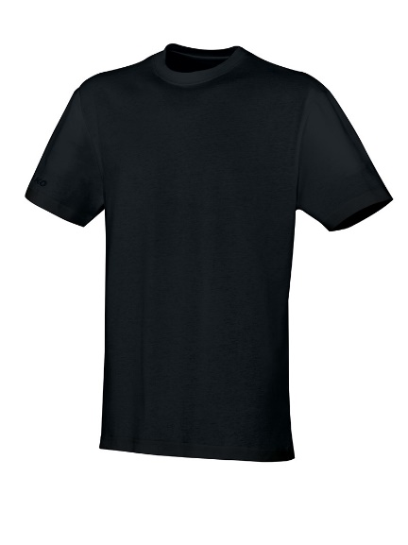](https://www.google.hr/url?sa=i&url=https://jako.hr/proizvod/majica-kratkih-rukava-team/&psig=AOvVaw2oZrZjfQI8RsoQ4aLtDqbv&ust=1604956791150000&source=images&cd=vfe&ved=0CAIQjRxqFwoTCIiD-I_w8-wCFQAAAAAdAAAAABAD)**

BEZ RUKAVA S DUGIM RUKAVIMA S KRATKIM RUKAVIMA

**i hlače:**

[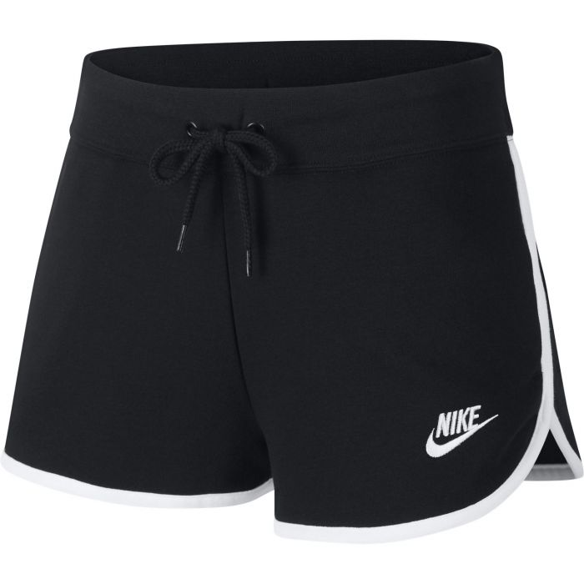](https://www.google.hr/url?sa=i&url=https://www.intersport.hr/nike-w-nsw-hrtg-short-flc-zenske-kratke-hlace-390645&psig=AOvVaw0d974LdO4NjJ6WAnV4HG49&ust=1604957027779000&source=images&cd=vfe&ved=0CAIQjRxqFwoTCMD044nx8-wCFQAAAAAdAAAAABAD) [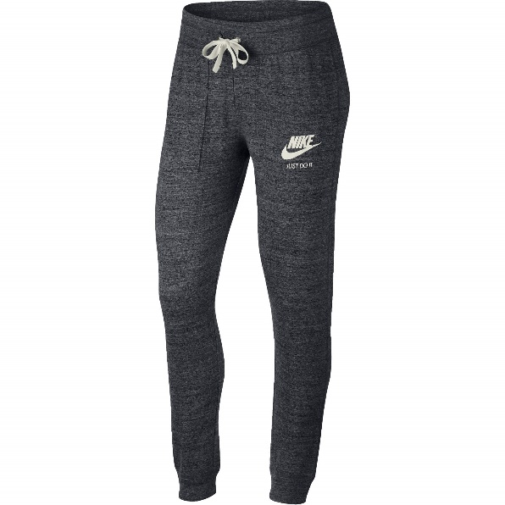](https://www.google.hr/url?sa=i&url=https://www.jeftinije.hr/Proizvod/10068032/zenska-odjeca/zenska-sportska-odjeca/zenske-sportske-hlace/nike-zenske-duge-hlace-crna-s-gym-vntg-pant&psig=AOvVaw34h4_mT_IgmZm78BTq4xJW&ust=1604957122603000&source=images&cd=vfe&ved=0CAIQjRxqFwoTCJjdi6_x8-wCFQAAAAAdAAAAABAD)

KRATKE DUGE

**Od obuće ću odabrati:**

**[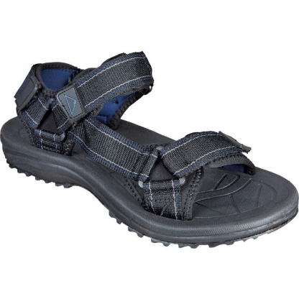](https://www.google.hr/url?sa=i&url=https://www.intersport.hr/mckinley-maui-m-muske-sandale-za-plninarenje-66597&psig=AOvVaw0qz8jd7pLoqSS5K227DUnI&ust=1604957296398000&source=images&cd=vfe&ved=0CAIQjRxqFwoTCIicyYjy8-wCFQAAAAAdAAAAABAD)** **[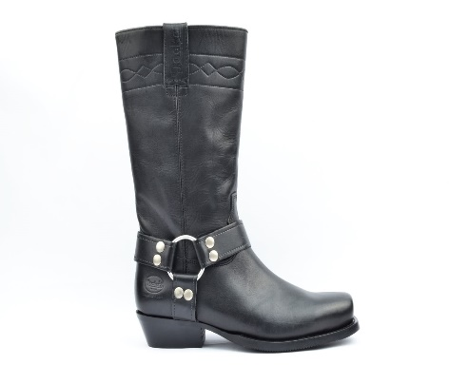](https://www.google.hr/url?sa=i&url=https://klub-kalifornija.com/detalji.php?s%3D030140-002001&psig=AOvVaw2p-uKVNCtCsZjx44T133Pq&ust=1604957359216000&source=images&cd=vfe&ved=0CAIQjRxqFwoTCKjOy6Hy8-wCFQAAAAAdAAAAABAD)**[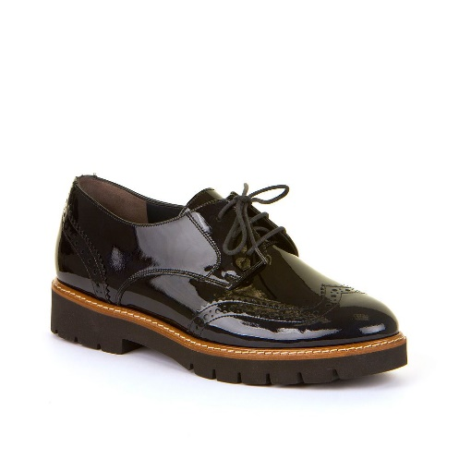](https://www.google.hr/url?sa=i&url=https://shop.ivancica.hr/proizvod/13023&psig=AOvVaw0gAp_A3XIuBxpwEfQknM-_&ust=1604957464255000&source=images&cd=vfe&ved=0CAIQjRxqFwoTCPiwx9Hy8-wCFQAAAAAdAAAAABAD)

SANDALE ČIZME CIPELE

Prvo pročitajte djetetu pitanje i pokažite slike. Dajte uputu neka pokaže sliku koja je točan odgovor i imenuje predmet na slici. Ako ne može, pročitajte pitanje i sva tri ponuđena odgovora, a dijete neka kaže naziv predmeta koji je točan odgovor.