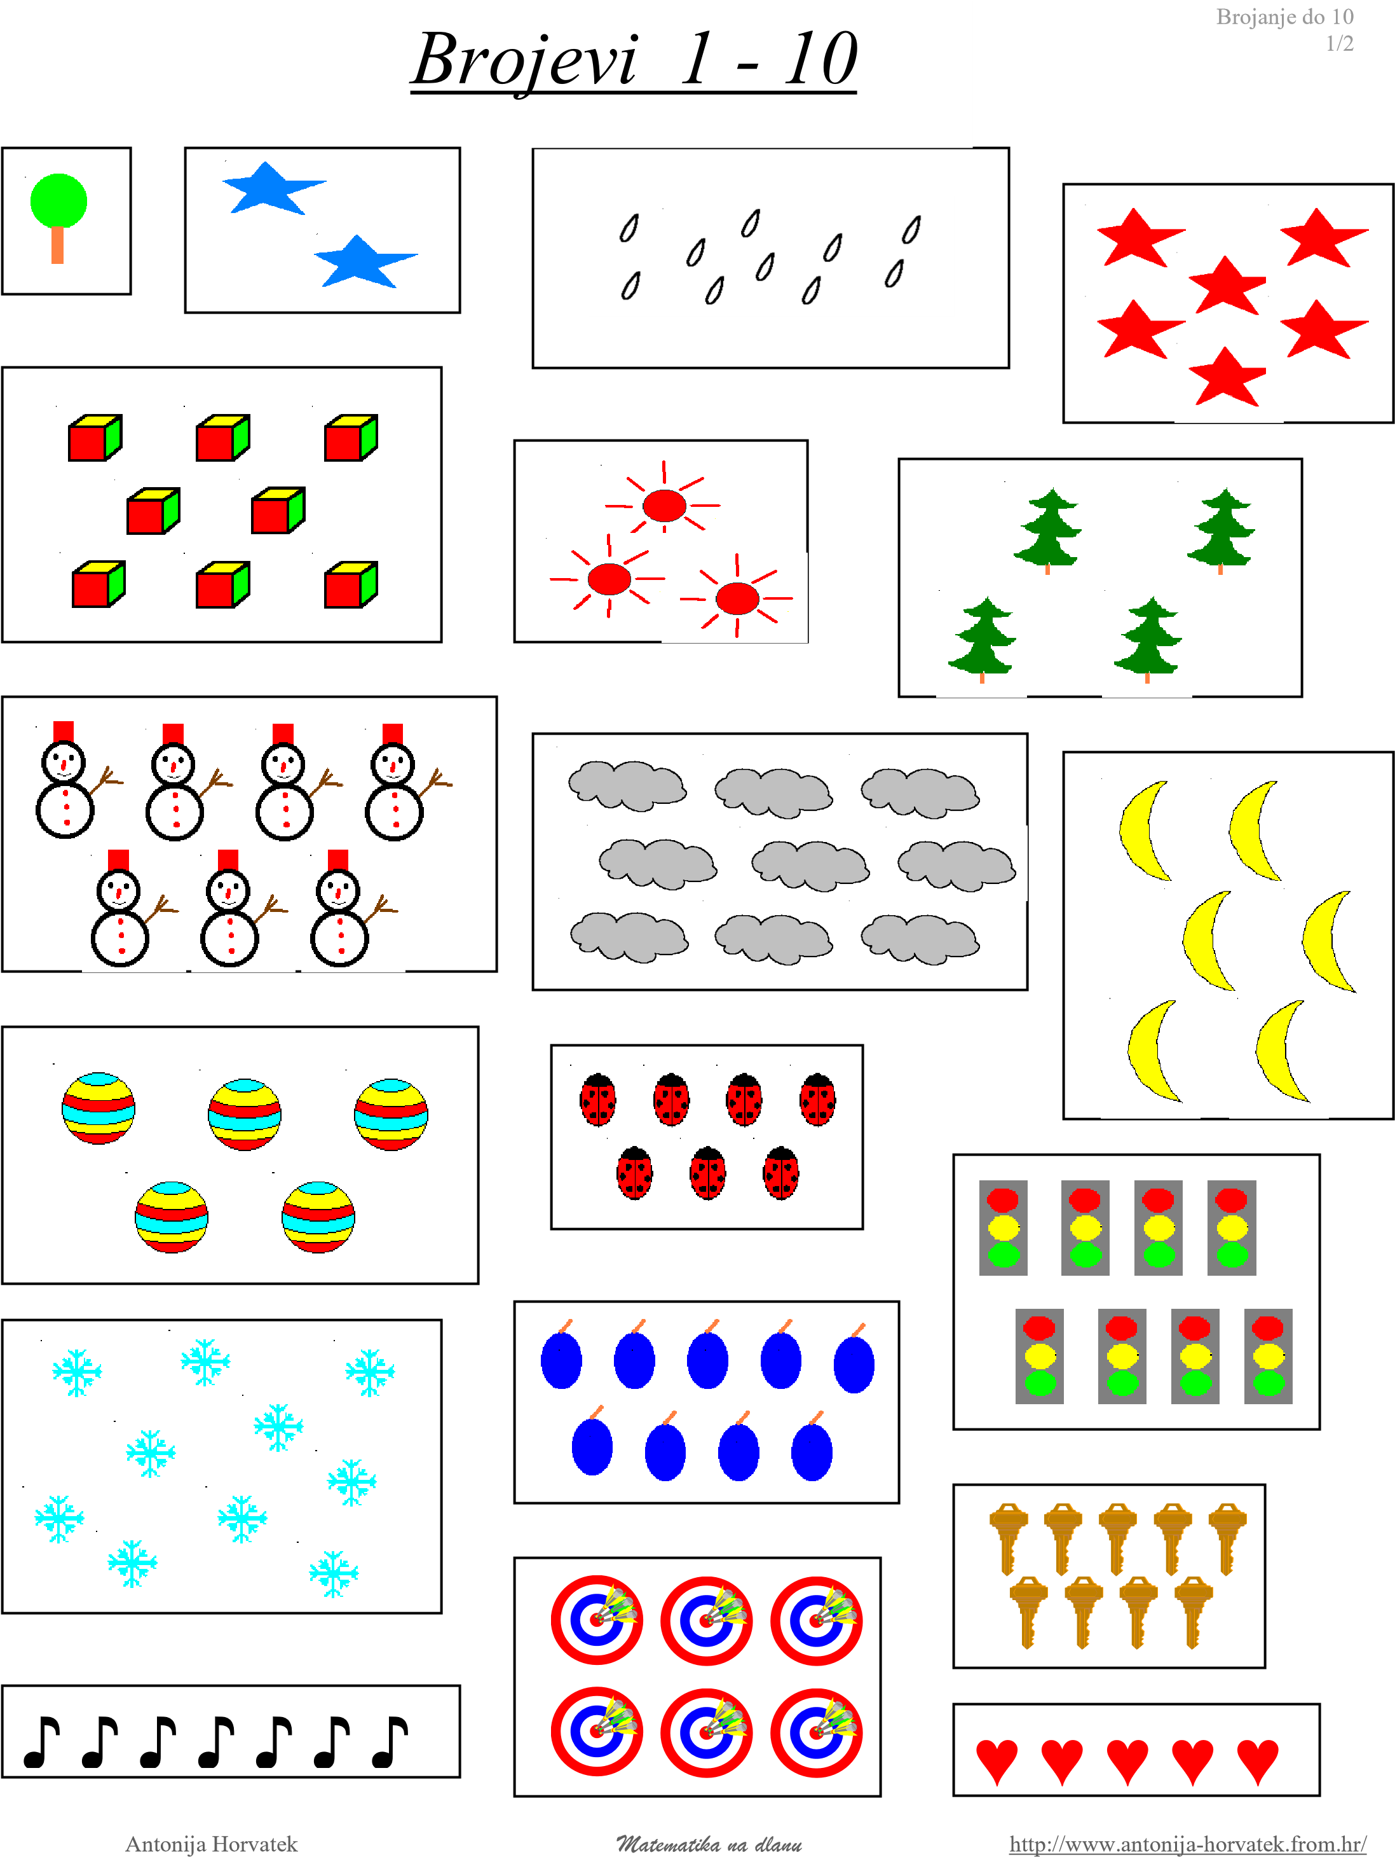

Brojanje do 10

# 2/2 Brojevi 1 - 10

*Ime i prezime: ______________________________________________________*

*Razred: _________________ Datum: _________________________________*

***Napiši koliko čega ima:***

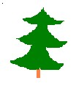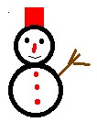

♪

♥

*Matematika na dlanu* http://www.antonija-horvatek.from.hr/

U RIJEČIMA PRONAĐI SLOVO I ZAOKRUŽI GA:

|  |  |  |  |  |  |  |  |  |  |
| --- | --- | --- | --- | --- | --- | --- | --- | --- | --- |
| ***j*** | ***m*** | ***v*** | ***n*** | ***l*** | ***a*** | ***o*** | ***u*** | ***i*** | ***s*** |
| jabuka | mama | vježba | minus | lastavica | čokolada | olovo | muha | sličice | slon |
| Mijo | lim | vjeverica | crno | lišće | vinarija | lopta | sluga | ribice | jesen |
| prijelaz | som | plivanje | plin | valovi | slava | konac | put | zvijezde | Jasna |

RIJEČI NEMAJU SVA SLOVA! NADOPUNI! M A M A

m__lena slov__ Jas__a __ova jese__

voli__ s__vo Mi__o Vu__o ja__e

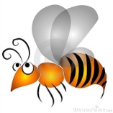

NADOPUNI REČENICE:

VAU-VAU

PAS LAJE __ __ __ - __ ___ __ . OKO NOSA LETI __ __ __ .