Fashion Contest !!!
THE GREEN SEWING MACHINE 2011
The aim of the contest is to encourage recycling and green way of thinking.
Participate alone or with a friend!
The rules: the clothing items presented for the contest must be made from old and used clothes. Accessories used can be new (e.g. pearls, spangles, buttons ).
The younger participants can use the help of their parents and teachers.
The deadline for presenting the final work is January, 31, 2012. In addition to the final outcome of the clothing item, there must be photos of the original clothes as well. You can choose a model to present the clothes and videotape the fashion show and take photos of every item of the collection.
The work will be assessed by a professional jury. Every country chooses its own jury and decides on the winners.
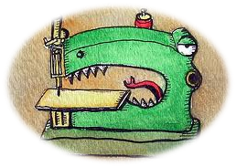
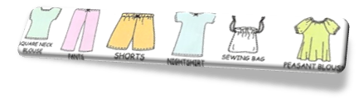

The winners get prizes from the Estonian Comenius team!

