Provjerimo znanje : Blizanke , Erich Kästner

**1. Odgovori na pitanja potpunom rečenicom.**

Koja je tema romana?_________________________________________________________________________

Kako su djevojčice saznale da su blizanke? ________________________________________________________

___________________________________________________________________________________________

Gdje su živjele djevojčice prije prvog susreta? ________________________________________________________

**2. Dopuni rečenice.**

U Zebilu na Bilskom jezeru nalazi se ________________________ _____________ za djevojčice.

Gospodin Palfi je po zanimanju ______________________, a gospođa Kerner je ______________________________ .

Lujza je najviše voljela jesti ____________________________ i igrati se sa svojim ___________________ .

Lota je bila uredna, pristojna i nosila je kosu ispletenu u ________________________________ .

**3. Zaokruži točan odgovor.**

|  |  |
| --- | --- |
| Tko je Peperl?  a) mačak  b) papagaj  c) pas  d) hrčak | Kojoj književnoj vrsti pripada ovo djelo?  a) basni  b) romanu  c) pripovijetci  d) igrokazu |
| Gđa Kerner je živjela u ?  a) Berlinu  b) Beču  c) u Münchenu  d) Dresdenu | U kojem je gradu živio gosp. Palfi?  a) u Dresdenu  b) u Berlinu  c) u Beču  d) u Münchenu |

**4. Napiši nekoliko osobina :**

Lota : _________________________________________________________________________________________

Lujza : _________________________________________________________________________________________

Pouka : _________________________________________________________________________________________

**5. Poredaj naslove prema tijeku događanja**. Pored svakog odgovarajućeg naslova upiši dijelove fabule : UVOD, POČETAK, ZAPLET, VRHUNAC, RASPLET, KRAJ

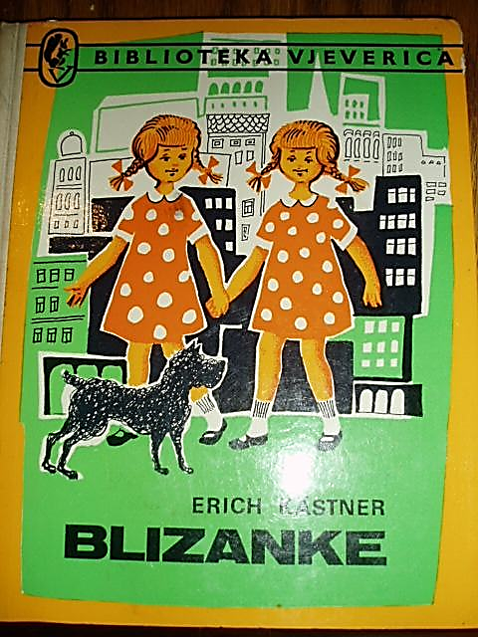____ Odlazak majke i Lujze u Beč

____ Upoznavanje sestara blizanki

____ Razotkrivanje dječje zamke

____ Zamjena blizanki

____ Obitelj opet zajedno

_1__ Odlazak na ljetovanje u ferijalni dom