St. Michael fortress in Sibenik
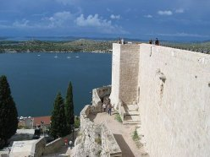
User rating

4.0 (1)
Hits: 3144
The fortress of St. Michael in Sibenik was built on a 60m high limestone hill situated at the mouth of the river Krka. This is the place where the life of Sibenik began. The town of Sibenik was mentioned for the first time in 1066, in the documents signed by the Croatian King Petar Kresimir IV. The building of the present-day fortress lasted from the 13th to the 18th century but its biggest part belongs to the 15th and 16th century. Its ground plan has the shape of an irregular quadrangle. In the eastern part of the fortress there are two well preserved square mural towers and there are two polygonal towers in its northern part. The Gothic style main entrance is situated on the eastern side. During the archeological excavations inside the fortress territory, numerous objects, dating from the prehistoric period to the Middle Ages, were uncovered. According to the historical sources from the 12th century, inside the fortress walls there was the church of St. Michael.
Along the course of its history, the fortress was damaged and rebuild several times. It was demolished twice, in 1663 and in 1752 by the explosion of the powder-magazines situated within its walls. There is a double defensive wall descending from the fortress to the coast and ending with the big Gothic gate. It was built at the beginning of the 15th century and, in danger, the soldiers used it to retreat towards the sea.
Image Gallery
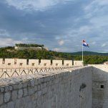
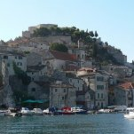
Worth seeing (and hikking)
Our family of four started a one day trip to Sibenik from Murter on a cloudy day. At the arrival to Sibenik we saw that impressive fortress at the top of the whole city and we thought at once how wonderful must be the view from above. Actally, it was even better than we imagine. At the top we thought that there would be a spot where you can buy water and drinks but there wasn't. A very nice gentleman from Sibenik explained the whole story about the permissions and thet it wasn't doable to have that kind of shops here (because it is a very important historical monument). So, remember, bring your bottle of water with you.
Reviews:
Don't miss:
the view.
Try to avoid:
not bringing a bottle with water.
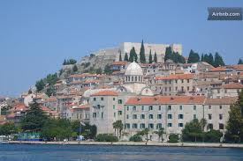
For other places with the same name, see Šibenik (disambiguation).
Šibenik
— Town —
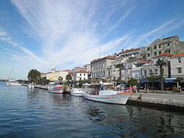
Šibenik harbor and town center
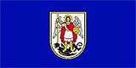  Flag | 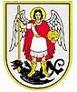  Seal

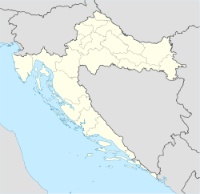
Šibenik
Location of Šibenik within Croatia
Coordinates: 43°44′N 15°55′E
Country | Croatia
County | Šibenik–Knin County
Government
• Mayor | Dr. Ante Županović
Elevation | 0 m (0 ft)
Population (2011)^{[1]}
• Town | 46,372
• Urban | 34,242
Time zone | CET (UTC+1)
• Summer (DST) | CEST (UTC+2)
Postal code | 22000
Area code(s) | 022
License plate | ŠI
Website | http://www.sibenik.hr/
Šibenik (Croatian pronunciation: [ʃîbe̞niːk]) is a historic town in Croatia, located in central Dalmatia where the river Krka flows into the Adriatic Sea. Šibenik is a political, educational, transport, industrial and tourist center of Šibenik-Knin county.
Name
In Croatian, the town is known as Šibenik, in Latin as Sebenicum, in Italian as Sebenico, in Serbian as Шибеник, in Hungarian as Sibenik, in Albanian as Shibeniku, and in German as Sibennig.
History
Early history
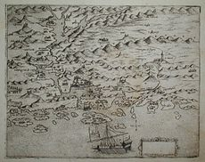
Early 16th century map of Šibenik by Martino Rota.
Unlike other cities along the Adriatic coast, which were established by Greeks, Illyrians and Romans, Šibenik was founded by Croats.^{[2]} Excavations of the castle of Saint Michael, have since proven that the place was inhabited long before the actual arrival of the Croats. It was mentioned for the first time under its present name in 1066 in a Charter of the Croatian King Petar Krešimir IV^{[2]} and, for a period of time, it was a seat of this Croatian King. For that reason, Šibenik is also called "Krešimirov grad" (Krešimir's city). It is the oldest native Croatian town on the eastern shores of the Adriatic.
Between the 11th and 12th centuries, Šibenik was tossed back and forth among Venice, Byzantium, Hungary and the Kingdom of Bosnia. It was conquered by the Republic of Venice in 1116,^{[3]} who held it until 1124, when they briefly lost it to the Byzantine Empire,^{[4]} and then held it again until 1133 when it was retaken by the Kingdom of Hungary.^{[5]} It would change hands among the aforementioned states several more times until 1180.
The city was given the status of a town in 1167 from Stephen III of Hungary.^{[6]} It received its own diocese in 1298.^{[2]}
Under Venice and the Habsburgs
The city, like the rest of Dalmatia, resisted the Venetians in a three-year war that was resolved in their favor in 1412.^{[2]} The Ottoman Empire started to threaten Šibenik, as part of their struggle against Venice, at the end of the 15th century,^{[3]} but they never succeeded in conquering it. In the 16th century, St. Nicholas Fortress was built and, by the 17th century, its fortifications were improved again by the fortresses of St. John (Tanaja) and Šubićevac (Barone).
The fall of the Venetian Republic in 1797 brought Šibenik under the authority of the Habsburg Monarchy.^{[3]}
After the Congress of Vienna until 1918, the town (bilingual names ŠIBENIK- SEBENICO) was (again) part of the Austrian monarchy (Austria side after the compromise of 1867), head of the district of the same name, one of the 13 Bezirkshauptmannschaften in Dalmatia.^{[7]} The Italian name only was used until around 1871.
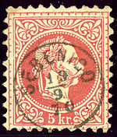
Austrian KK stamp, cancelled in Italian Sebenico in 1870
In 1872, at the time in the Kingdom of Dalmatia, Ante Šupuk became the town's first Croat mayor elected under universal suffrage. He was instrumental in the process of the modernization of the city, and is particularly remembered for the 1895 project to provide street lights powered by the early AC Jaruga Hydroelectric Power Plant.
20th century
After World War I, Šibenik was occupied by the Kingdom of Italy until 12 June 1921. As a result of the Treaty of Rapallo, the Italians gave up their claim to the city and it became a part of the Kingdom of Serbs, Croats and Slovenes. During World War II it was occupied by Fascist Italy and Nazi Germany. Over the course of Allied bombing of the city, the Church of Sveti Nikola (Saint Nicholas) in the Mandalina settlement was destroyed.^{[8]} After WWII it became a part of the SFR Yugoslavia until Croatia declared independence in 1991.
During the Croatian War of Independence (1991–1995), Šibenik was heavily attacked by the Yugoslav National Army and Serbian paramilitary troops.^{[3]} Although under-armed, the nascent Croatian army and the people of Šibenik managed to defend the city. The battle lasted for six days (16–22 September), often referred to as the "September battle". The bombings damaged numerous buildings and monuments, including the dome of the Cathedral of St. James and the 1870-built theatre building.
In an August 1995 military operation, the Croatian Army defeated the Serb forces and freed the occupied areas,^{[3]} which allowed the region to recover from the war and continue to develop as the centre of Šibenik-Knin county. Since then, the damaged areas of the city have been fully reconstructed.
Climate
Šibenik has a Mediterranean climate, with mild, humid winters and hot, dry summers. January and February are the coldest months, July and August are the hottest months. In July the average maximum temperature is around 30 °C (86 °F).
[show]Climate data for Šibenik
Main sights
Main article: Cathedral of St. James, Šibenik
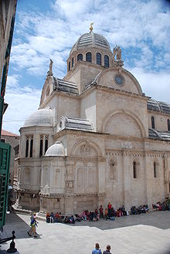
St. James's cathedral.
The central church in Šibenik, the Cathedral of St. James, is on the UNESCO World Heritage list.
Several successive architects built it completely in stone between 1431 and 1536,^{[2]} both in Gothic and in Renaissance style. The interlocking stone slabs of the Cathedral's roof were damaged when the city was shelled by Serbian forces in 1991. The damage has since been repaired.
Fortifications in Šibenik
Main article: St. Nicholas Fortress
In the town of Šibenik there are four fortresses:
- St. Nicholas Fortress (Croatian: Tvrđava Sv. Nikole) is a fortress located at sea, at the entrance of Šibenik's port.
- Tvrđava Sv. Mihovila
- Tvrđava Sv. Ivana
- Tvrđava Šubićevac
Natural heritage
- A couple of kilometers north of the city is the Krka National Park, similar to the more famous Plitvice Lakes National Park, renowned for its many waterfalls, flora, fauna, and historical and archaeological remains.
- The Kornati archipelago, west of Šibenik, consists of 150 islands in a sea area of about 320 km², making it the densest archipelago in the Mediterranean Sea.^{[10]}
Culture and events
The annual Šibenik International Children's Festival (Međunarodni Dječji Festival) takes place every summer.
The composer Jakov Gotovac founded the city's "Philharmonia Society" in 1922. The composer Franz von Suppé was part of the city's cultural fabric, as he was a native of nearby Split.
Population
St. Nicholas Fortress
From Wikipedia, the free encyclopedia
Jump to: navigation, search
St. Nicholas Fortress
Tvrđava Sv. Nikole
Šibenik Dalmatia
Croatia
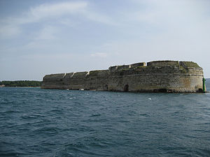
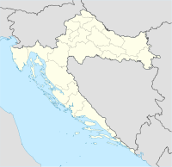
Shown within Croatia
Type | Fortress
Coordinates | 43.722°N 15.854°ECoordinates: 43.722°N 15.854°E
Built | 1540.-1547.
Built by | Hyeronimus di San Michaela
Construction  materials | Limestone
Current  condition | Preserved
Current  owner | Šibenik, Croatia
Open to  the public | Yes
Controlled by | Republic of Venice
St. Nicholas Fortress (Croatian: Tvrđava Sv. Nikole) is a fortress located in the town of Šibenik, one of the oldest native Croatian towns on the eastern shores of the Adriatic, in central Dalmatia, Croatia.
Contents
- 1 History
- 2 Architecture
- 3 Notes
- 4 See also
- 5 External links
History
In the town of Šibenik there are four fortresses:
- St. Nicholas Fortress (Tvrđava Sv. Nikole)
- St. Michael Fortress (Tvrđava Sv. Mihovila)
- St. John Fortress (Tvrđava Sv. Ivana)
- Šubićevac Fortress
Only St. Nicholas Fortress is at sea, at the entrance of Šibenik port, and the other three are on land.
St. Nicholas Fortress was built on the left side at the entrance of the St. Anthony (Sv. Ante) channel, on the island called Ljuljevac, in front of the Šibenik port. St. Nicholas Fortress got its name from the Benedictine Monastery of St. Nicholas, which was on the island, but due to construction of the fortress had to be demolished. At the request of domestic Croat population of Šibenik, the Venetian captain Alojzije de Canal decided to build a fort on an island of Ljuljevac in 30 April 1525. Fortress was designed and built by the famous Venetian architect and builder Hyeronimus di San Michaela. It was built by in the 16th century to prevent Turkish boats from reaching the port. St. Nicholas Fortress was armed with 32 cannon. However, its imposing appearance and size were a bigger threat to the enemy than canons.
Architecture
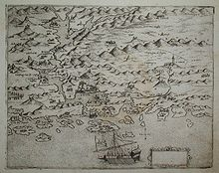
ST NICHOLAS FORTRESS
is at the entrance of the St. Anthony channel on the map from 16th century
The fortress is one of the most valuable and best preserved examples of defense architecture in Dalmatia. The fortress is made of brick because this material was considered to be most resistant to cannon balls, while the foundations are made of stone. Although defense capabilities of the fortress have never been tested in military operations, the structure still proved successful in protecting the city from sea-bound enemy attacks. During the centuries of use, the structure served to various armies and has undergone a number of renovations, some of them made necessary because of the development of arms. It was completely abandoned by the military in 1979 and has been in renovation ever since.
Notes
In the Mediterranean, there are two similar forts: one on the island of Malta, and the other is in Venice, and her name is Saint Nicholas.

ST. JOHN'S FORTRESS
St. John's fortress is located on the hill, 115 m high above the old town centre of Šibenik.
It was built up in 1646 in the form of a star according to the project of the Venetian military engineer Antonio Leni,
in order to protect the town from Turkish attacks from the hinterland.
It is interesting that the construction of the fortress lasted for only one month and a half (six weeks)
because the inhabitants of Šibenik were afraid of Turkish attacks so they helped building it up, too.
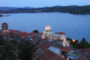

ŠUBIĆEVAC FORTRESS
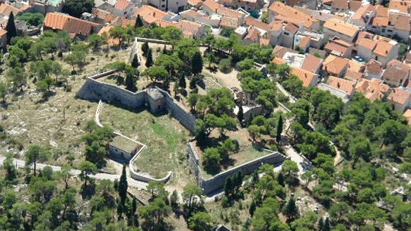
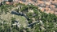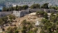
Šubićevac fortress is located south-east of St. John's fortress and a couple of meters lower than St. John's fortress.
It was constructed in the same year as St. John's fortress, in 1646 and it contributed very much to the defence of the Town of Šibenik from the Turkish attacks in 1647. For a long time it was named the fortress of the baron Degenfeld, after the Venetian soldier of the German origin that lead the defence of the town from the Turks.
Tvrđava Šubićevac (tvrđava Baron Degenfeld) smještena je sjeverno od stare gradske jezgre Šibenika, nekoliko stotina metara jugoistočno od tvrđave Sv. Ivana. Nalazi se na 80 metara nadmorske visine, na brdu koje se zove Vidakuša, zbog toga što se tu, prije gradnje tvrđave, nalazila mala crkva Sv. Vida. Izgrađena je 1646.g., u isto vrijeme kad i tvrđava Sv. Ivana, te je zajedno s njom igrala značajnu ulogu u obrani grada od Turaka 1647.g. Dugo vremena nosila je ime po barunu Degenfeldu, Nijemcu u službi Mletačke Republike, vođi obrane Šibenika od 1646. do 1647. 1659. proširio ju je i rastaurirao Antun Bernardo, koji je to isto učinio i s tvrđavom Sv. Ivana. Gradsko vijeće Šibenika kupilo je tvrđavu te njeno okolno područje 1912.g. i nazvalo taj dio grada Šubićevac po staroj hrvatskoj plemićkoj obitelji Šubića. Tvrđava Šubićevac malo je manja od tvrđave Sv. Ivana, ali je lakše pristupačna posjetiteljima. S nje se pruža prekrasan pogled na stari grad, šibenski kanal Sv. Ante i otoke šibenskog arhipelaga.
Kategorije:
- Utvrde u Hrvatskoj
- Građevine u Šibeniku

