Europe day

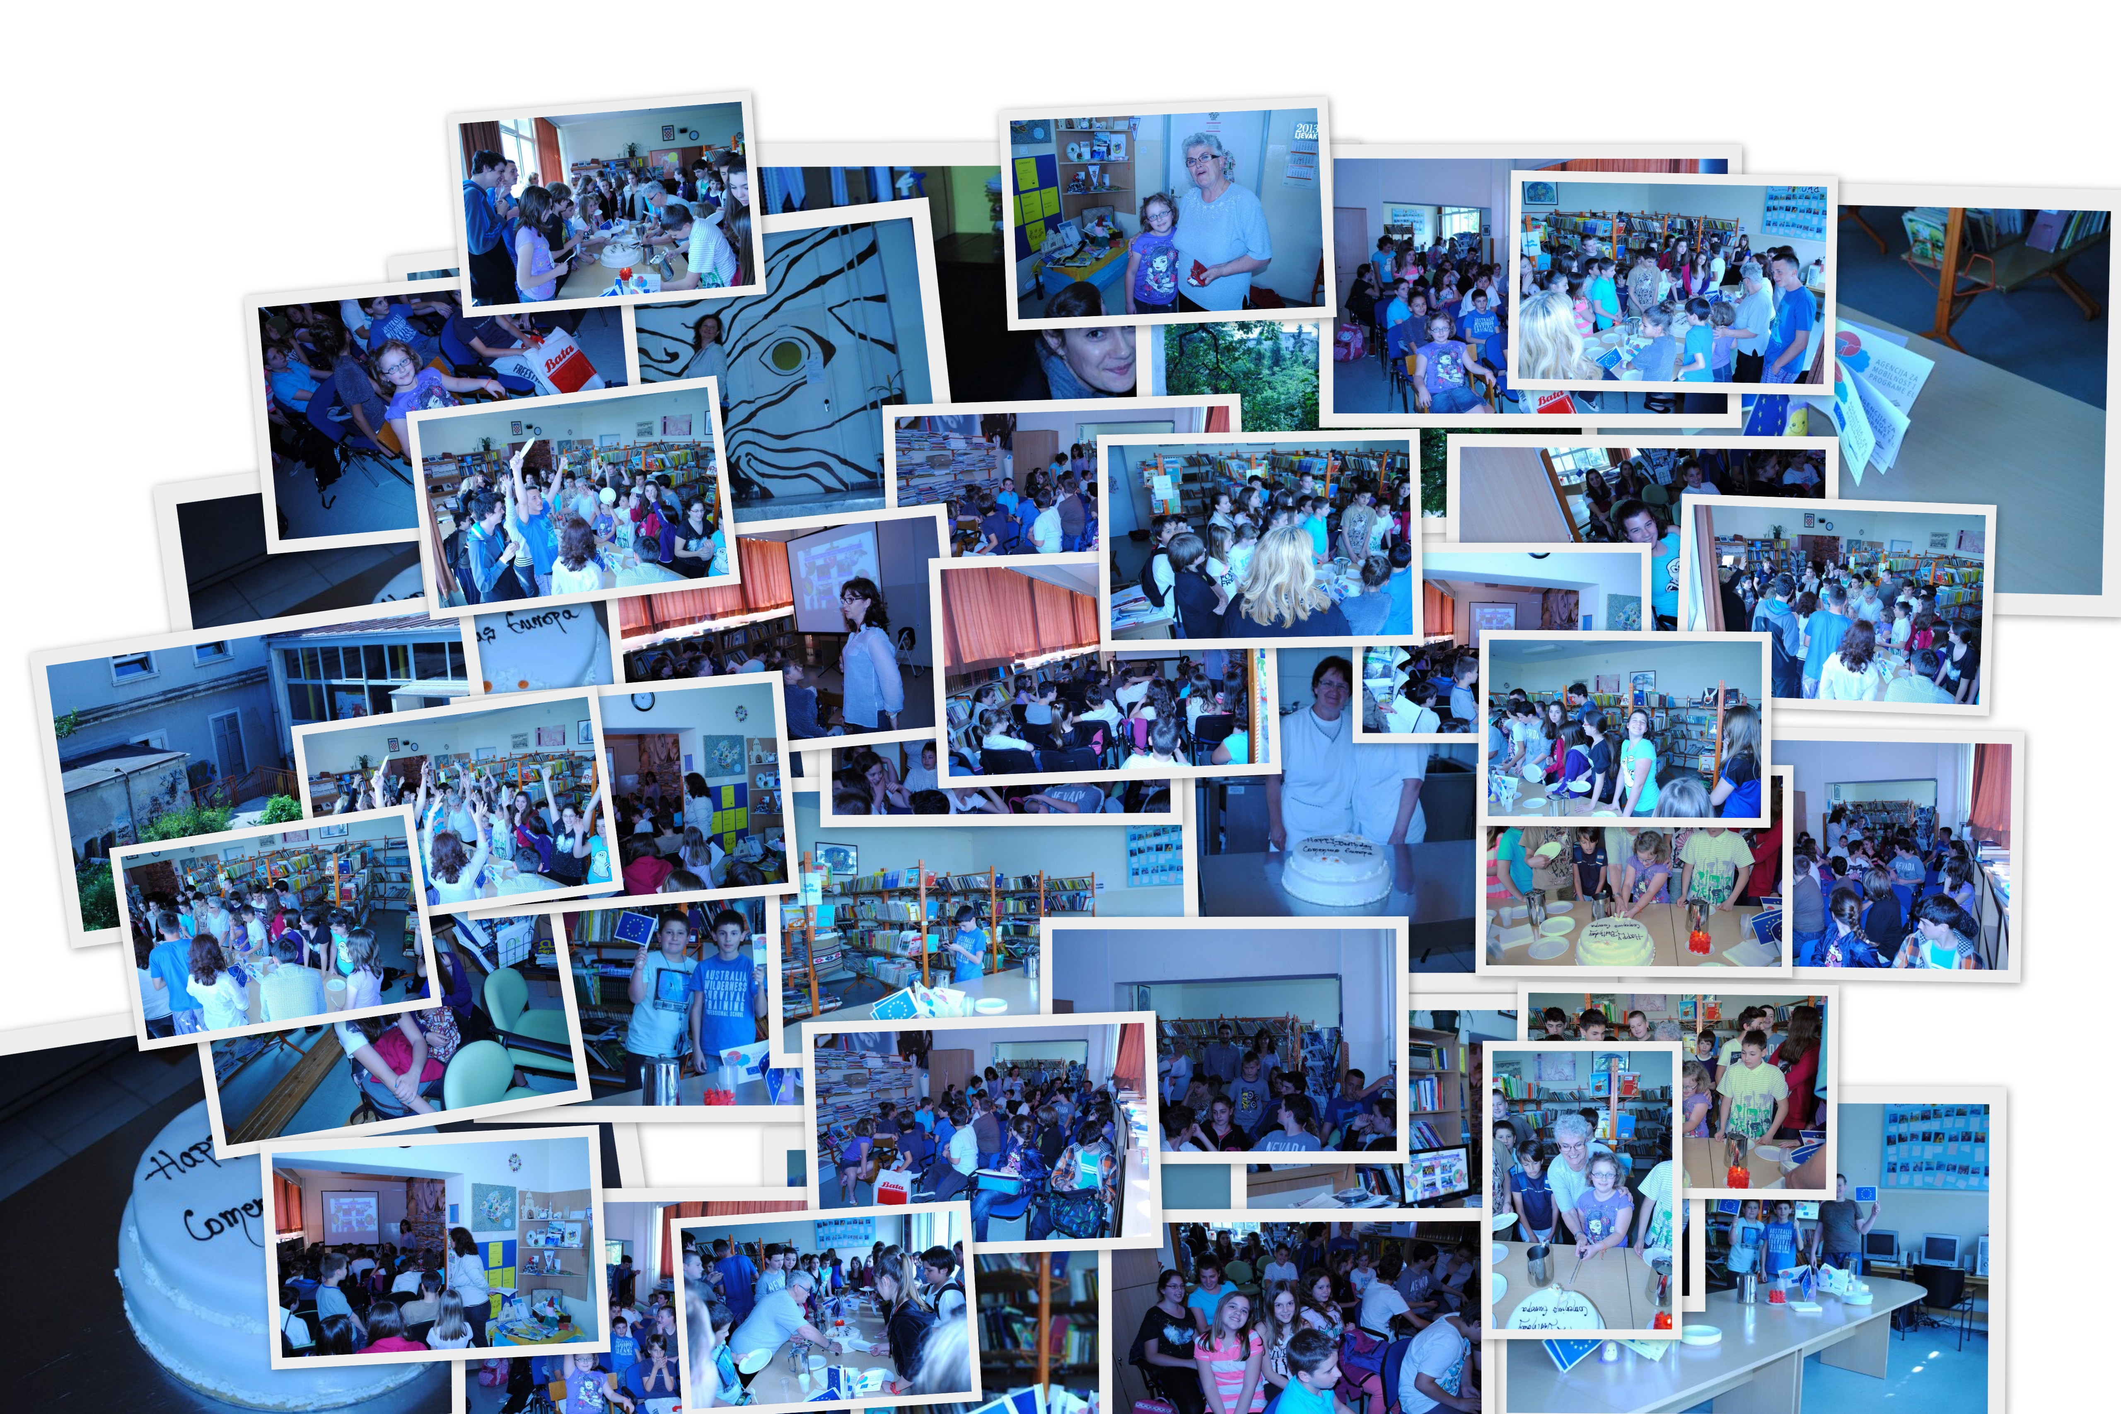

Birthday parties of Europe and birthday of our students !

