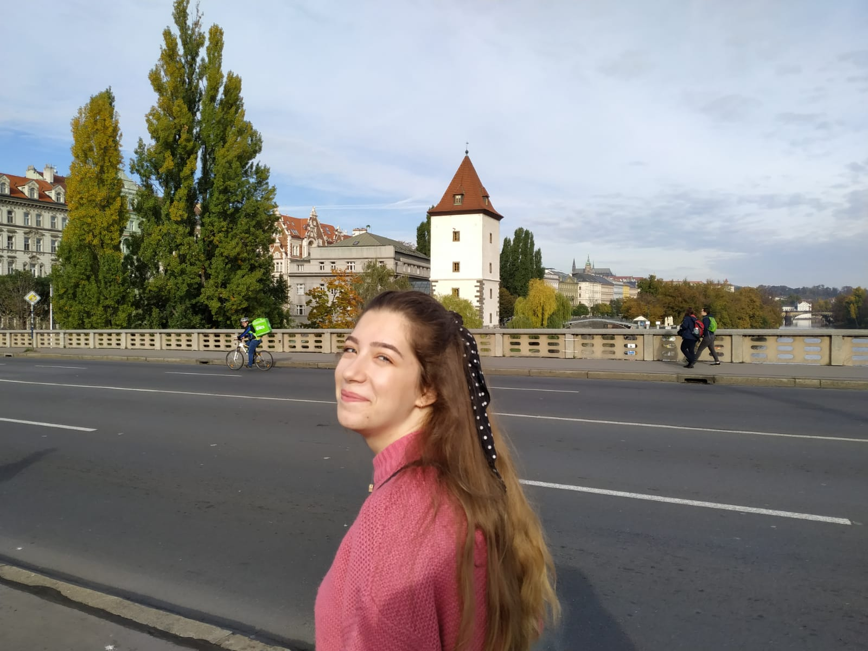

Hi!
My name is Karla, I'm 16 years old and I come from a small village on the island of Brač called Ložišća. I have two brothers, Ivan is 23 and Josip is 14 and he is in high school.
Since I live in a village, my family owns a land where we have olive trees. And beacuse of that I've always enjoyed spending time in nature and also I'm a huge animal lover, I especially love cats since I've always had them.
Maths has always been my favourite subject in school, but I love the languages too and lately I've been really into geography since my dream is to travel the world. For me school at times is really difficult and boring, but in those times I think about the reason I came to this school which is being able to get into the college I want. I still don't what I'm going to study, but I'm almost sure it's something connected to math and biology.
I love listening to music and in the past I've learnt how to play the guitar but for some reason I stopped, and I really do regret that. Now I love reading books and watching movies. I've always been quite shy but in the past year I became sociable and now I like spending time with my friends. I also love volunteering, last year i volonteered in a tennis match and a bike race.
I'm not really passionate about anything special, but Erasmus+ has in a way become my passion. This project made me realize the importance of travelling, that it isn't about the fancy hotels or expensive dinners, but it's about the people. Beacuse if the company is good, nothing else matters. I've been on two Erasmus+ trips and this is my first time being in a host family and I couldnt be more excited.

