RAZLIKOVNI ISPIT I PREDMETA ''MJERENJA U ELEKTROTEHNICI''
UČENIK: _____________________
DATUM: _____________________

- Očitaj vrijednost na zaslonu osciloskopa, izračunaj efektivnu vrijednost tog napona i odredi frekvenciju.
a)
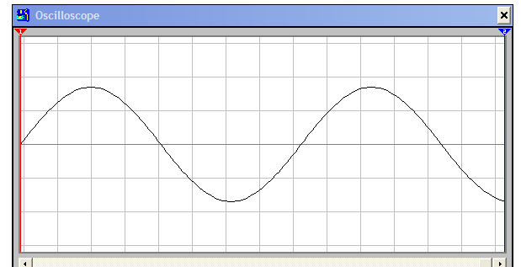

ky=100 V/div Y= _____________

Umax= ________Uef= ___________

kx= 0,002 s X= _____________

T= _____________ f=______________
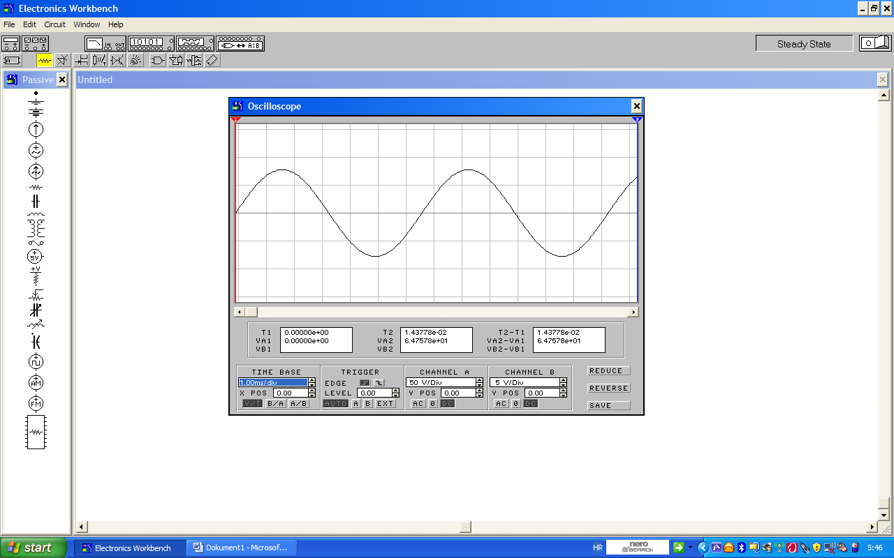

b)
ky=50 V/div Y=______________

Umax= __________ Uef= ___________

kx= 0,001 s X= _____________

T= _____________ f=______________

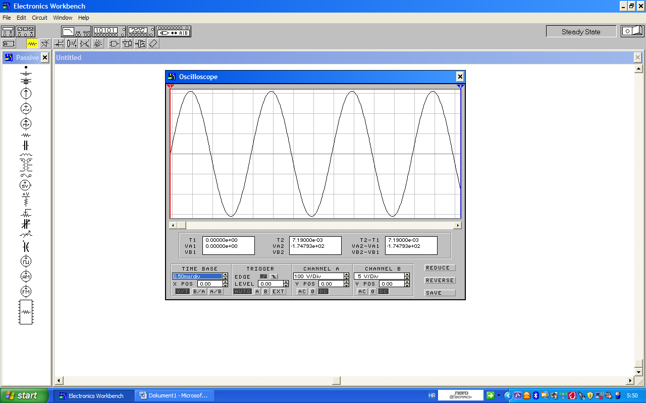
c)

ky=100 V/div Y=______________

Umax= __________ Uef= ___________

kx= 0,0005 s X= _____________

T= _____________ f=______________

d)
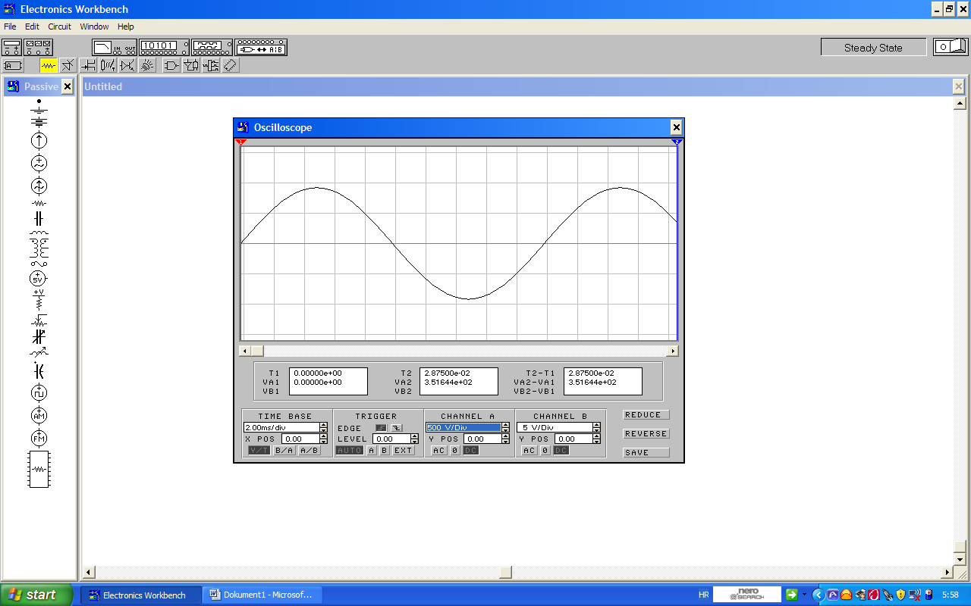

ky=500 V/div Y=______________

Umax= __________ Uef= ___________

kx= 0,002 s X= _____________

T= _____________ f=______________

e)
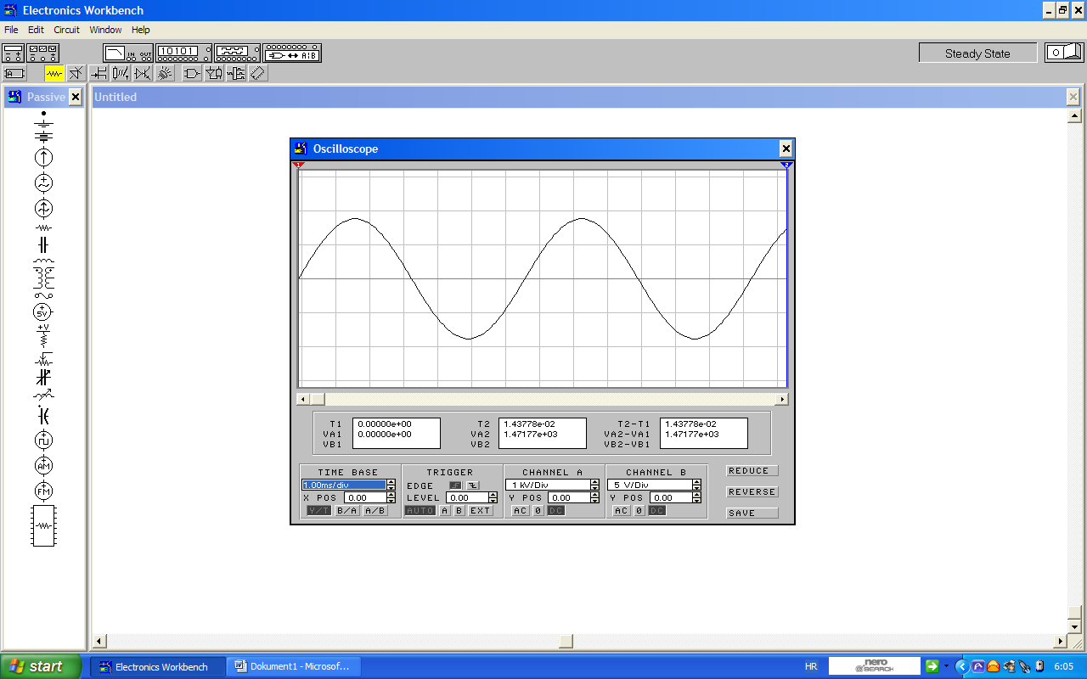

ky=1000 V/div Y=______________

Umax= __________ Uef= ___________

kx= 0,001 s X= _____________

T= _____________ f=______________

