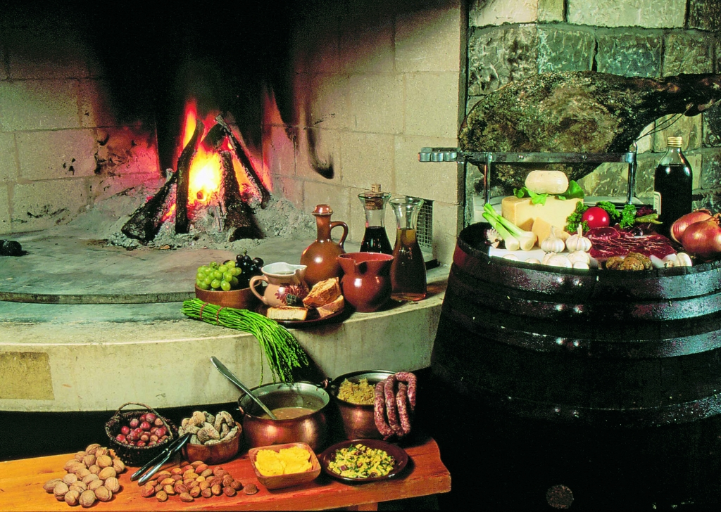

|  |
| --- |
| ISTRIAN  CUISINE |
|  |
| sš mATE BALOTE  „Europe is what it eats“ |



# FIREPLACE - OGNJIŠĆE

|  |
| --- |
| Fireplace is the oldest interior in the house. It is loaded with clay-loam and surrounded by a stone,as a wreath of rocks and a small part was scheduled for baking and it was lined with brick.  Fireplace was rectangular shape.  An integral part of the fireplace and make komaštre,healds,bronzvik,pots,roasting,waving,the poker and other.Komaštre hung on gregi spots.The home hearth took up a central position along the gable of the house,so it has plenty of space to sit by the fireplace,and sleep. |
| Fireplace,a special place in the house where he explained the open fire to heat the room and cooking.In the Croatian rural homes several forms hearth kept in the application even in the 20th century.It was the simplest low hearth of rammed clay,placed on the floor in the middle of the room,without a special device for the smoke that was coming through the plain hole in the roof,is characteristic of pastoral huts in mountain regions Croatian.In the Adriatic is home fireplace was located along začelni wall or in a separate alcove kitchen(chapel or tornice in Istria and Primorje).It could be clay,elevated 20 cm from the ground or more(about 50 cm),with the combustion surface of the brick,laid on wooden legs and surrounded by a wooden frame,was the hearth high 80 cm with the recess in the front surface of the ash disposal or firewood.Smoke protective cap(a barrel of wattle-coffins or polupiramidalnom of planks-hood) directed the furnace to the chimney.On the transferse beam above the fireplace was locked chain(chain,komoštre) with a hook for receiving containers.Common accessories with fireplace contained:a circular or triangular metal tripod as a base for pots,ceramic or metal shaped container for baking(baking,baking tin),barbecue in the form of a metal grill (grill);rack lean logs (Prijeklade),sometimes ornamental implemented; poker; blower to fan the fire and more.Along the sides of the homes were often placed benches with backs.The symbolic meaning of the hearth as the former center of family life evident in many rituals.So,for example,a marriage ceremony the bride at the entrance to the house led three times around the fireplace,where she pročarkala coals and it gave(money or apple),on Easter Sunday,the fire rolled over firebrand adopted by the Paschal bonfire; fireplace(and the Yule-log on to him) sacrificed on Christmas Eve,a special meal consisting of nine ingredients and drinks and the like. |
| ISTRIAN HAM - PRŠUT  Istrian ham is cured meat product,processed on the Istrian way with and without pelvic bones,dry cured with sea salt and natural spices,dried in the air and no smoke.  For proper drying and ripening of ham under natural conditions most deserving winds are north and northeast and east wind from Učka.Natural conditions in Istria provide an ideal environment for the traditional production of the Istrian ham,because to the influence of the Mediterranean climate there are no extremely low temperatures,and the area is frequently refreshed by winds.  Ham is made from pigs weighing from 150-200 kg that are grown for their own needs,and today the production has considerably expanded for tourism.The last 20-30 years are grown white and meaty swine breeds such as Large White,Swedish Landrace,German Landrace and their hybrids.  Feeding pigs for the production of Istrian ham is based on:beets,pumpkin,patatoes,corn and grains.Pigs are often kept grazing,however,in their diet and still find oak acorns,roots,etc.  Hams are dry-cured in sea salt with the addition of pepper,bay leaves,rosemary.Drying and ripening process lasts 12-18 months to draft the premises protected from the entrance of flies and other insects.  Characterized by a specific aroma and flavor,moderately salty taste,uniform red color and desirable consistency.  Istrian ham is the best representative of culinary art and tourism in Istria.Ham is used in many dishes,and one of the most popular in our country are Istrian pasta-pljukanci with ham and asparagus. |
| PEKA, ČERIPNJA  Meat under the bell is among the top gastronomic Istrian cuisine. Today on offer there is a variety of electric peka, i.e bellsunder which the meat is baked, however the original preparation of the meat is in a metal bell and it is prepared on fire from real wood (mash). Food is put in a shallow pan and then is covered with an iron bell for which in Istria there are different names: baking lid, Čripnja, lopiz. We usuually prepare meat, squid, octopus or bread with the addition of various vegetables (usually potatoes) under the bell. |
| ISTRIAN FUŽI  Fuži are traditional Istrian pasta,which is prepared by the pastry thinly rolled and cut into strips the width of 3-4 cm and placed over one another.  Noodles are then cut through diagonally to form diamond-shaped.The two ends of each rhombus is then wrapped around each other and in the middle are pressed to look like an onion.  Served with a mild red beef sauce that usually saves of onions,tomatoes,white wine and broth.  Here are also famous fuži with asparagus,tomato juice,bacon and truffles. |
| PLJUKANCI  Pljukanci are traditional Istrian pasta,which is very quick and easy to prepare by rubbing between your hands. Flour is sieved to make it softer,so 500 grams with the addition of salt,olive oil and warm water is kneaded dough. Stirred until it becomes elastic.Onion is cleaned and fried in olive oil on which we crushed garlic. Mushrooms are diced and added to the onion and mix thoroughly to flavor imbued.Let it fry over low heat while stirring occasionally mixes and leak all wine and chicken broth. Pljukanci dusted with and shaken so as not to tape it.Heated water in a pot,add the salt and cook the pasta in it.We shake pljukanci to good schedules by sauce.With us are known pljukanci with summer mushrooms, sausages, asparagus and bacon and truffles. |
| PORK LOIN  Zarebnjak,ombolo or žlomprt are names used in some parts of Istria which called meaty part of pork chops.The meat is separated from bones rub the salt,crushed pepper and crumbled leaves of laurel.So meat is left to dry for two to three weeks.Served cut into slices as cold cuts or pepper on the grill or in a pan with olive oil.      ISTRIAN SAUSAGES  Pork meat ground in the rough,salt it and pepper.Cleaned garlic mashed knife and bolt it in wine.  Well all mix,a mixture of charged hose and sausage shape.Sausages hung on a long stick and dry for 10 to 15 days of the hearth. Among them,put the laurel branches.Can be fried in oil,save the vine,on the grill,after 15 days can be eaten raw as salami,make them tomato sauce. Dried can be stored in the freezer,in oil or fat.With us is the most famous scrambled eggs and thick soup with sausages.    MANEŠTRA  Maneštra is authentic Istrian dish prepared from various vegetables, and regardless of the form still contains grains of corn. Popular in the entire northern Adriatic. It is served as an appetizer if the main ingredient in vegetables, but it can be served as a main dish if it contains "more ingredients" such as meat. |
|  |
| CUKERANČIĆI    Istrian cukerančići were named after the sugar.In Istria has no significant family celebrations or holidays without these traditional cakes.They were required at weddings,christenings,,confirmations , Holy Communion , and today you can find them as part of the traditional gastronomic offer in the hotels and restaurants , especially in the supply of taverns and rural households in the interior of Istria.Their preparation is quite demanding.All additives are mixed in a dough that should not be too hard,but must be smooth and soft and should not knead it too long it would warm the hands.Let dough rest for half an hour to an hour.Then split the dough into two pieces and roll out with a roller.Dough cut into strips and then they shape.There are several ways of creating these cakes,depending from which part of Istria originate.  We can shape them eg in the form of a letter x or horseshoe-shaped,then we match them in a baking pan lined with baking paper and bake in the heated oven to 190 degrees and bake for 10-15 minutes until slightly golden.  Hot baked biscuits dip in brandy or white wine,and then profusely roll them in granulated sugar and leave to dry.As long as stand they are the better. |
|  |
| FRITULE  Fritters are Croatian dessert that resembles a small donut , and are prepared in the Kvarner Riviera, Istria and Dalmatia . In Primorje and Istria is customary to do in the days of fasting , Christmas Eve and during the carnival . They are very similar to Italian epaulettes , but usually they are added liqueur , brandy and lemon peel , may contain raisins and sprinkle the sugar . They can be prepared from yeast dough with yeast or dense batter and baking powder .  Ingredients :  400 g of flour , 2 yogurt ( liquid ) , 3 or 4 eggs , 80 g sugar , a little bourbon vanilla (optional ) , grated lemon peel ( oranges ) , baking powder , 2 tablespoons brandy , salt , one grated apple ( Granny Smith ) , raisins (optional ) , cooking oil , sugar (powdered ) for sprinkling  Procedure:  Beat eggs and add sugar and yogurt , brandy , bourbon vanilla , lemon zest and / or orange and a little salt .  In to the mixture slowly add the flour in which you have previously added baking powder mix it well and add the finely grated apple. The mixture can , if desired, add dried raisins .  The mixture let stand for 15 minutes and in the meantime, heat the oil in a deep pan . Fritters must swim in oil , so make sure that you have enough , but that is not too hot to prevent them from burning .  The mixture remove the spoon and gently drop into the hot oil and fry until golden.  Be careful not to overload the fritters oil, because in this case will not be able to turn themselves in oil .  Take them on kitchen paper and , if desired, sprinkle with powdered sugar or regular |
| KROŠTULE  Kroštule traditional sweet common in the coastal part of Croatian . Often they prepare for the holidays and various celebrations , and are made from a simple dough that is cut into thin strips and formed into a loose knot and fried in deep fat . The dough for the Dalmatian fritters usually flavored brandy or fruit liqueur , while the Istrian fritters mainly used white wine .  Ingredients:  2 eggs , 3 tablespoons brandy or liqueur ( kirsch , limoncello etc. ) , 2 tablespoons rum 4 tablespoons of melted butter , 1 tablespoon sugar , 1 tablespoon vanilla sugar, lemon zest 1žličica , a pinch of salt , about 400g of flour ( half strongly , half smooth), cooking oil , powdered sugar for sprinkling  Procedure:  In a large bowl whisk create eggs, brandy, rum, melted butter, sugar, vanilla sugar, lemon zest and salt. Gradually add the flour, stirring with a wooden spoon. Continue adding flour until you get a firm elastic dough that is not sticky. The dough should be similar consistency as the dough for pasta or noodles. You may need to use more flour than specified, and may not need to use all 400g. It depends on the size of eggs and flour quality. Knead the dough for 2-3 minutes on a lightly floured surface, then wrap it in plastic wrap and let rest for 30 minutes at room temperature. Dough divide into two parts and each part separately roll out as thin, approximately 2 mm thick. You can use the machine for pasta, if you have one. Dough decorative wheel cut into strips the size of 2 cm x 20 cm strips so each tie in a loose knot. Stack nodes on a tray sprinkled brašnom.U thick bottom pan warm up the oil for frying. Fry fritters repeatedly, turning them occasionally, until they are nicely crispy and slightly swollen, 2-3 minutes. Kroštule may not get brownish. Fried fritters remove to a paper towel to the eyes, then sprinkle with powdered sugar. Serve warm or cold. Keep them in tin of biscuits. |