# ­

Biology

Congeria lives its entire life in the caves, adjusting specific way of life;

complete loss of pigment and reduction of light receptors.

It feeds on small organic particles by filtering water.

A unique reproductive system is preset. The females protect fertilized eggs

between the gills until a larvae develops, which after a short planktonic phase, either

attaches to a surface or develops to the full adult stage.

**Congeria Kusceri is categorized as critically endangered**.

Pure underground waters are on of the main necessities for the life of cave faune,

but also for humans on the surface.

Protecting habitat of the Dinaric cave clam, we protect a

significant resource - a source of drinking water.

Genus Congeria with its three species:

* Kusceri
* Jalzici
* Mulaomerovici

are the only bivalve in the world who live in the underground.

They are also the only surviving representatives of Congeria which was widespread during the Tertiary.

**Therefore, they are living fossils and tertiary relics.**

The entire genus Congeria was considered extinct until 1934th when the shells of those

bivalvae were found near Stinjevac in Vrgorac (Dalmatia, Croatia).

It was only in the 1953. that the alive specimens were found in the abyss of Žir in

Popovo polje, BiH.

Based on this interesting finding, Slovenian malacologist Bole Jože described the new

species for science, Congeria Kusceri, devoting its name to the malacologist Ljudevit Kuščera.

LOCATION



*Cave entrance*

*Location of the cave and Congeria kusceri*



*Congeria kusceri*

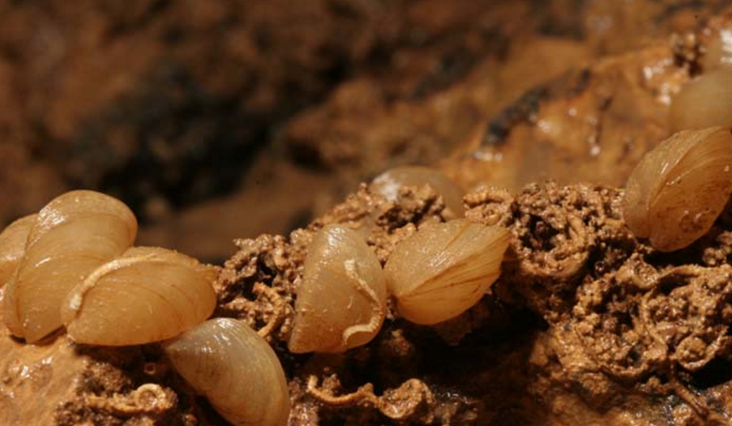

What is Congeria?